**// Subroutine : UpdateButtonClick_CUSOMTIZE_BACKDETAILS()**

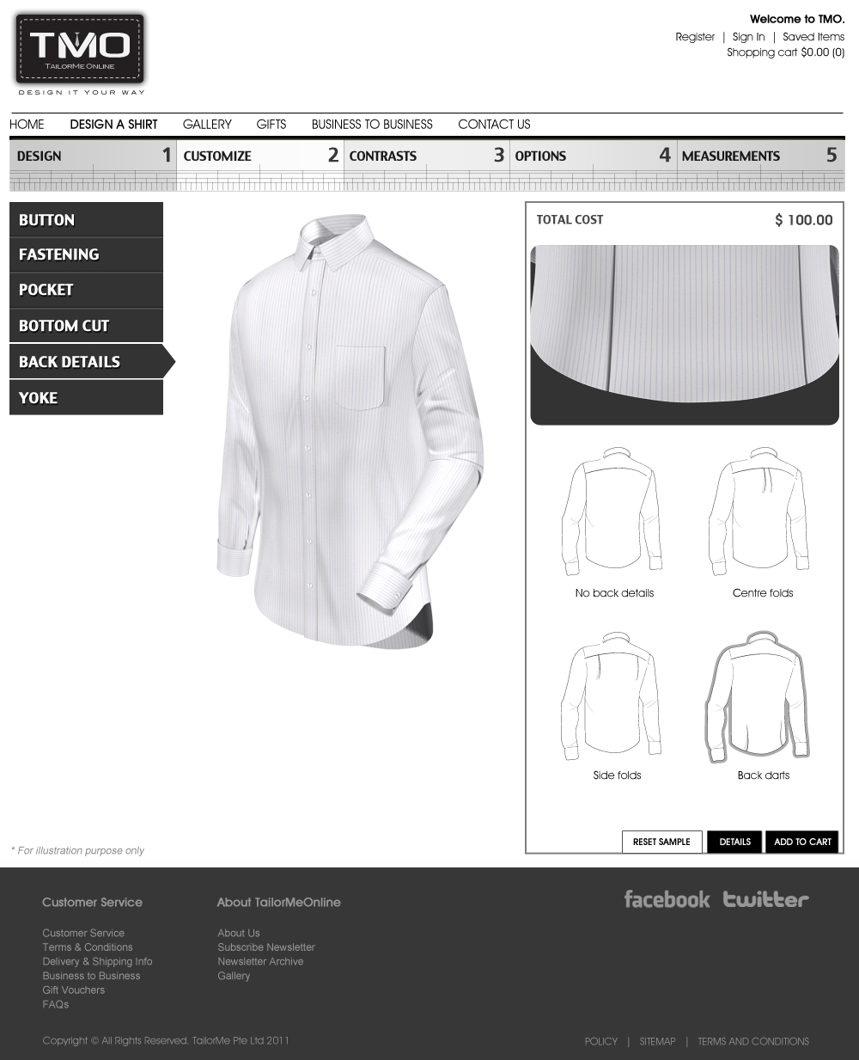

Upon clicking “No back details”:

BackDetails[2] = “”;

BackYoke[2] = “ClassicYoke.”;

Call Subroutine : RefreshFilenames();

Call Subroutine : DisplayBackYoke(); // This displays the back yoke

Upon clicking “Centre folds”:

BackYoke[2] = “ClassicYokeCentreFold.”;

Call Subroutine : RefreshFilenames();

Call Subroutine : DisplayBackYoke(); // This displays the back yoke

Upon clicking “Side folds”:

BackYoke[2] = “ClassicYokeSideFold.”;

Call Subroutine : RefreshFilenames();

Call Subroutine : DisplayBackYoke(); // This displays the back yoke

Upon clicking “Back darts”:

BackDetails[2] = “BackDart.”;

Call Subroutine : RefreshFilenames();

Call Subroutine : DisplayBackDart(); // This displays the back dart

**// End of Subroutine : UpdateButtonClick_CUSOMTIZE_ BACKDETAILS()**